# CACCC Resource Database Documentation - Table of Contents

Table of Contents 1

CACCC Resource Database Documentation - Usage 2

How to connect to the database 2

The Main Page – “Resource List” 2

The “Add a Resource” Page 3

The “Edit Resource” Page 3

CACCC Resource Database Documentation – Maintenance 5

Prerequisite Software 5

Updating prerequisite software 5

First time installation 5

Folder structure & how updating works 5

How to start the database 6

Troubleshooting Errors 8

# 

# CACCC Resource Database Documentation - Usage

## How to connect to the database

1. Open a web browser on your computer.
2. In the address bar, type in localhost:3000It’s recommended that everyone keeps this as a bookmark, so they don’t have to remember this.
3. If the address is unknown, see “How to find the IP address of the machine running the database” in the maintenance documentation.

## The Main Page – “Resource List”

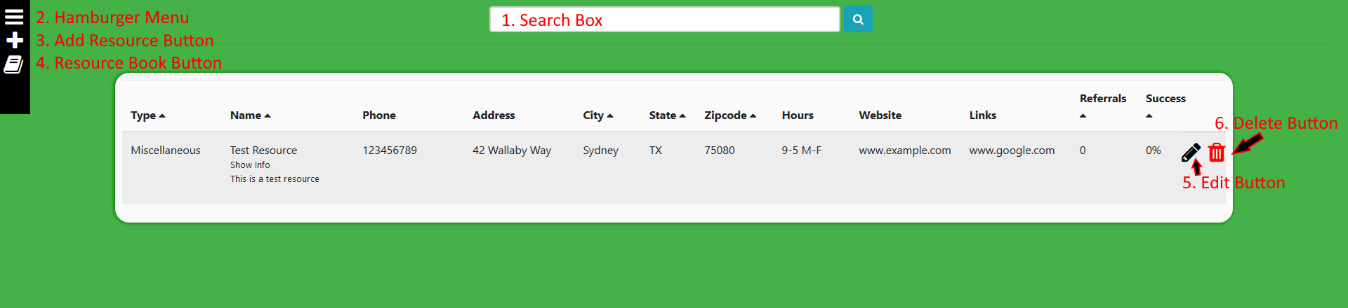

1. **Search Box** – You can type something here to try and find a specific resource. It searches by Name, Type, Address, Phone, Zip Code, City and Website all at once. You can type any of those in to find what you’re looking for. This will always be at the top of the page no matter where you are on the site.
2. **Hamburger Menu** – Click this to expand the menu on the left. It will reveal an option so filter the resources by type. This menu will stay here no matter where you go on the site.
3. **Add Resource Button** – Clicking this will take you to the “Add a Resource” page.
4. **Resource Book Button** – Clicking this will take you back to the “Resource List” page and reset all type filters/search results.
5. **Edit Button** – Clicking this will take you to a new page to let you edit that resource and to submit a referral.
6. **Delete Button** – Clicking this will delete a resource. This is permanent, but it will prompt you to ask if you’re sure.
7. Extra notes: You can click any of the column titles with a triangle next to them to sort by that column. Also, if you hover over “Show Info” it’ll expand like in the picture above and show the resource description.

## The “Add a Resource” Page

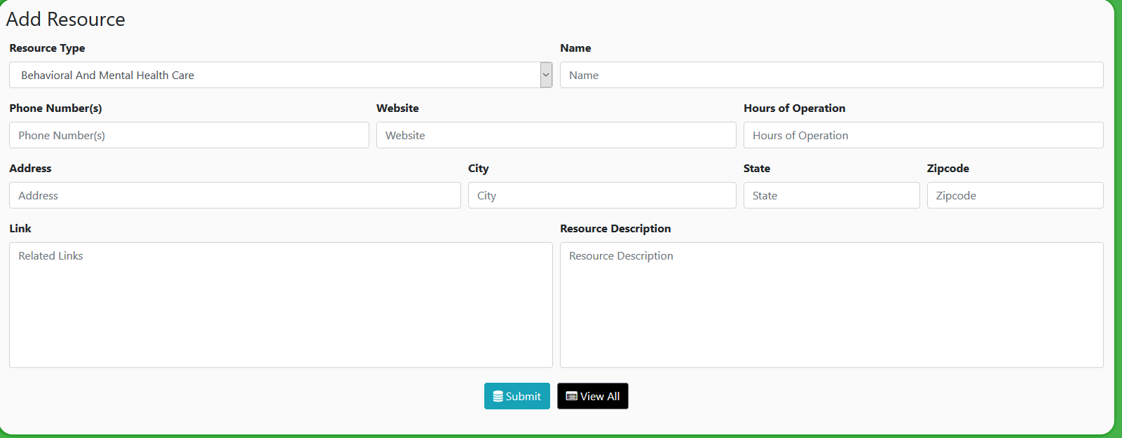

Here you can create a new entry into the database. Fill out whatever information you need to (doesn’t have to be everything!) and click submit to save into the database. Clicking “View All” will take you back to the main page and discard whatever you were working on.

## The “Edit Resource” Page

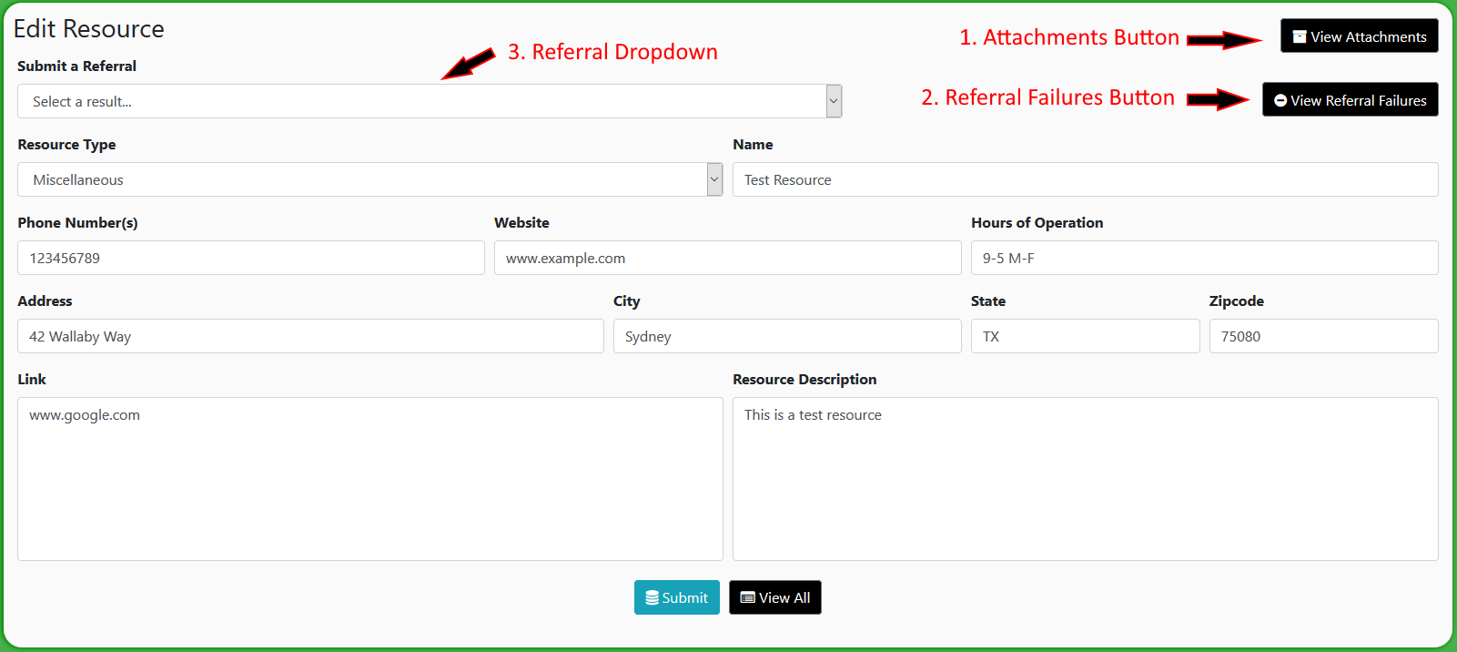

This page is similar to the “Add a Resource” Page, with a few additions:

1. **Attachments Button** – This will take you to a page where you can view/upload files that correspond to the resource (like flyers, pictures, etc.).
   1. **View of the attachments page**: 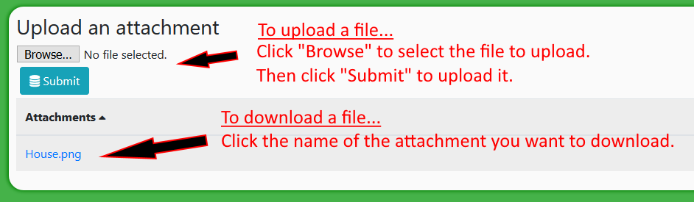
2. **Referral Failures Button** – Clicking this will display a small window detailing how many/what kinds of reasons people have had their referrals fail.
3. **Referral Dropdown** – Selecting this will display a bunch of results of a referral. If you don’t select anything, a new referral will not be submitted. If you select “successful,” a successful referral will be submitted. If you selected anything prefixed with “Failed:” a failed referral will be submitted. The system keeps track of how many referrals of each category were submitted.
4. Notes: remember, nothing will change until you click the “Submit” button. Marking a referral or making any edits will not do anything until the submit button is clicked.

# CACCC Resource Database Documentation – Maintenance

## Prerequisite Software

|  |  |
| --- | --- |
| **Software Name** | **Current Version** |
| MongoDB | ^3.5.7 |
| Python | 3.8.1 |
| Node.js | 12.14.1 |
| Git | 2.25.0 |
| Docker Desktop | 20.10.13 |

## Downloading prerequisite software

* **Docker Desktop**:
  + Go to the Docker Desktop website: [docs.docker.com/desktop/windows/install](https://docs.docker.com/desktop/windows/install/)
  + Click on “Docker Desktop for Windows” and Download
  + Go to [https://docs.microsoft.com/en-us/windows/wsl/install-manual#step-4— download-the-linux-kernel-update-package](https://docs.microsoft.com/en-us/windows/wsl/install-manual#step-4---download-the-linux-kernel-update-package) and download the “WSL2 Linux kernel update package for x64 machines”
  + Type in “wsl --set-default-version 2” into the computer terminal
  + Restart Computer and open Docker. Docker should say “Running” and then “No Containers Running” if working.
  + Download Linux Distribution (Ubuntu 20.04 Preferred)
  + To manually run the container: type in “docker run --name mongo -p 27017:27017 -v caccc-db:/data/db -d --rm mongo” in terminal

## Updating prerequisite software

* **MongoDB**: after updating, make sure that in Settings.txt, the “Mongo Path” line contains the path for the new mongod.exe file.
* **Python/Node.js/Git**: Make sure that these executables are updated in the PATH environment variable.

## First time installation

* Install all the prerequisite software and make sure that python, node.js, and git were all added to the PATH environment variable correctly (already installed on the PC from EPICS).
* Follow the steps in “how to start the database” to set up automatic startup

## Folder structure & how updating works

* The “repo” folder
  + This contains all of the executable files that run the server.
  + It does not and never should contain any files that need to be saved.
  + It is overwritten every time the server is updated with the latest version from the GitHub repository (<https://github.com/utdEPICS/CACCC_Resource_Database>)
    - To update the server, pull the repo from GitHub.

## How to start the database

The database is started through the start.ps1 (Windows) and/or start.sh (Mac) files.

1. Clone (first installation) or pull (update) the repository from GitHub
   1. <https://github.com/UTDallasEPICS/CACCC_Resource_Database>
2. Make sure Docker Desktop is on before starting the database.
3. Go to the CACCC_Resource_Database folder
4. Click on either start.ps1 (for Windows users) or start.sh (for Mac users) after Docker Desktop is running.



## Troubleshooting Errors

* Error in DB Connection : MongoNetworkError: failed to connect to server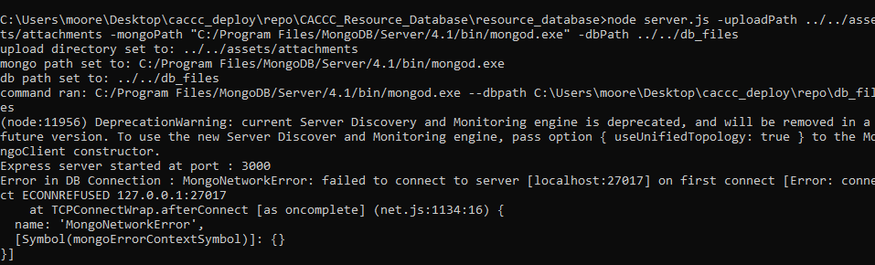
  + This means that the resource database was not able to connect to MongoDB.
  + If this doesn’t work, check the firewall settings.
  + If there’s no issue there, delete the repo folder and re-clone the repository.
* No one can connect to the database
  + Make sure the IP address of the host computer has not changed.
  + Make sure there are no errors in the server console.
  + Try restarting the server/computer.
  + Check to see if the host computer is plugged into the right network (not law enforcement)
  + Check the firewall and make sure node.js has access to networking